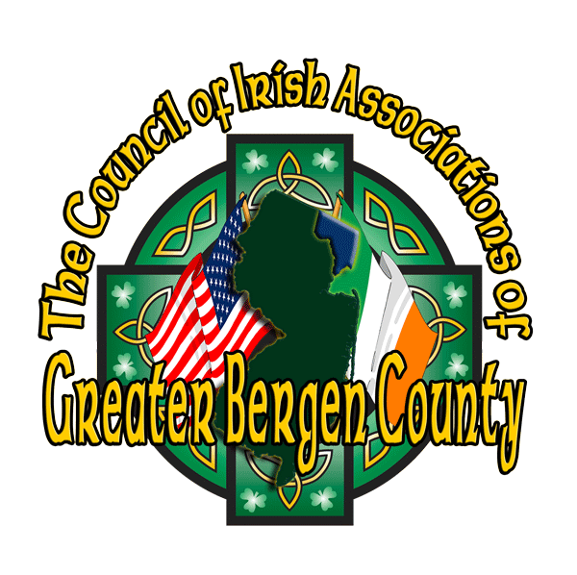

# The Council of Irish Associations of

# Greater Bergen County, Inc.

Post Office Box 5113

Bergenfield, New Jersey 07621

February 27, 2025

To: High School Guidance Counselors:

The Council of Irish Associations of Greater Bergen County, Inc., a tax-exempt educational and charitable organization, announces the 2025 Kevin J. Duffy Memorial Scholarship Essay Contest. Named in memory of a past council member and president who upheld an inspiring vision of promoting Irish culture and heritage, each year the Council awards a scholarship of a thousand dollars to the winner and five hundred dollars to the second-place winner.

Open to all graduating high school seniors in Bergen County planning to attend an institution of higher learning, the essay contest is for the purpose of promoting awareness and knowledge of Irish and Irish-American culture.

Three topics in Irish and Irish-American studies are provided. The applicant may select one topic for the essay. The winner will receive a thousand-dollar scholarship, and the second-place winner will receive a five-hundred-dollar scholarship. The panel of judges is composed of educators and members of the Council.

Essay winners are encouraged to participate, if possible, in the Council’s annual Great Hunger Commemoration at the Bergen County Courthouse, attending the event to accept their scholarships and read their essays. This year’s Great Hunger Commemoration is scheduled for May 3, the first Saturday of May.

If there are any questions, please email: [EssayContest@BergenCountyIrish.org](mailto:EssayContest@BergenCountyIrish.org).

Respectfully yours,

Deirdre Spollen-LaRaia, Ed.D.

President



**The Council of Irish Associations of**

**Greater Bergen County, Inc.**

**2025 Kevin J. Duffy Memorial Scholarship Essay Contest**

In the interests of increasing awareness of Irish culture, the Council of Irish Associations of Greater Bergen County, Inc., would like to announce an essay contest for high school seniors. This year’s essay topics have an international focus, exploring the historical connections between Ireland and other nations and peoples.

● *Like many other nations, the Irish experienced raids by the Vikings in the closing centuries of the first millennium. Research the history of Viking raids and settlements in Ireland. What were those centuries of conflict like? How did the Irish fare compared to other nations? What lasting impacts did the Viking invasions have on Ireland?*

● *In the first half of the twentieth century, each of the two world wars forced Ireland to establish a position relative to Germany, a militaristic European superpower. During WWI, when Ireland was still under the control of Great Britain, many Irish enlisted in the British army to fight against Germany, while on the other hand, a group of Irish rebels coordinated with German forces in an attempt to stage an uprising against England. Two and a half decades later, Ireland maintained a position of neutrality during WWII, resisting England’s attempts to bring Ireland into the fight against Nazi Germany and the other Axis Powers. Research and discuss Ireland’s positions in these two wars, examining the strategic choices the nation faced as it was caught between England and Germany. What motivated Irish actions during these two wars? Do you believe these actions were justified?*

● *While America is perhaps the country most famous for its Saint Patrick's Day celebrations, the holiday is also celebrated in Mexico, largely in honor of St. Patrick's Battalion, known as the San Patricios, which fought on the side of Mexico during the Mexican-American War and was largely comprised of Irish immigrants to the US who defected to the Mexican side.  Research the history of St. Patrick's Battalion and its status in US and Mexican history.  Why did Irish-American soldiers defect to Mexico?  What were their accomplishments in the war?  Do you believe their actions were justified?*

The winner will receive a $1,000 scholarship, while the second place-winner will receive a $500 scholarship.

**Eligibility**

All high school seniors residing in Bergen County, New Jersey, who intend to enter college.

**Rules**

The essay must be no fewer than 600 and no more than 1,250 words in length, and must be typewritten and double-spaced. Since information is so readily available on the Internet, the student must show insight and understanding of the selected topic, with necessary attributions to sources. Works that show signs of AI use will be disqualified. An attached cover sheet must include the following**:**

|  |  |
| --- | --- |
| Your name and address and telephone number | Your selected college |
| Name and address of your high school | Topic selected (#1, 2 or 3 from list above) |
| Your counselor’s name & telephone number | References and/or sources used |

One entry per student, please. All entries must be made electronically no later than **Wednesday, April 16, 2025**. The essay must be solely the work of the entrant. The entry must include a completed cover sheet (available on the next page), as well as the essay itself, and should be sent to [EssayContest@BergenCountyIrish.org](mailto:EssayContest@BergenCountyIrish.org).

**Judging**

Essays will be judged on both style and content. Judges will look for writing that is clear, factual, articulate, and logically organized. The winning essay must demonstrate an understanding of the topic. The decision of the judges will be final.



# The Council of Irish Associations of

# Greater Bergen County, Inc.

**2025 Kevin J. Duffy Memorial Scholarship Essay Contest**

|  |  |
| --- | --- |
| Contestant’s Name, Address, & Telephone Number: | ______________________________________ |
|  | ______________________________________ |
|  |  |
|  | ______________________________________ |
|  |  |
|  | ______________________________________ |
|  |  |
| Contestant’s High School – Name & Address: | ______________________________________ |
|  |  |
|  | ______________________________________ |
| Contestant’s High School Counselor – Name & Telephone Number: | ______________________________________ |
|  |  |
|  | ______________________________________ |
|  |  |
| Contestant’s Selected College: | ______________________________________ |
|  |  |
|  | _____________________________________ |
|  |  |
| Topic Selected: | ______________________________________ |
|  |  |
|  | ______________________________________ |
|  |  |
| References and/or Sources: | ______________________________________ |
|  |  |
|  | ______________________________________ |
|  |  |
|  | ______________________________________ |
|  |  |
|  | ______________________________________ |
|  |  |
|  | ______________________________________ |
|  |  |